Return-to-Office Mandates: How to Lose Your Best Performers
Your organization’s highest-performing employees want executives to focus on outcomes and accountability, not office badge swipes.
Editor’s note: Since we originally published this story, even more data has come to light on the effects of RTO mandates. We have updated this story with a video in which Brian Elliott explores the newest RTO mandate research and lessons learned from company examples. He also shares predictions for what’s coming next for companies like Amazon that have imposed RTO mandates. Watch the embedded video at the bottom of this story.
Recent return-to-office (RTO) mandates like those at UPS and Boeing have a simple message: Come back to the office five days a week. CEOs cite productivity as a core reason for these proclamations, even in the face of employee resistance. Many executives simply don’t trust that employees are as effective as possible when managers can’t see them at their desks.
But in a world of globally distributed teams, falling back on management-through-monitoring is falling back on the weakest form of management — and one that drives down employee engagement. There is mounting evidence that mandates don’t improve financial performance. Instead, they damage employee engagement and increase attrition, especially among high-performing employees and particularly those with caregiving responsibilities.
There is a better way forward, but it requires culture work at the top as well as deep within organizations, along with a significant upgrade in management philosophy. Too many organizational cultures use face time at the office as their metric for productivity. That’s not the best benchmark. Instead, focusing on outcomes while providing trust and flexibility about where and when to get work done allows individuals and organizations to thrive.
What’s Behind the RTO Drive
We’re four years past the start of the pandemic-driven shift toward flexible work. While the peak of remote work has passed for now, office utilization in the U.S. has been effectively flat. For the past year, it’s been hovering at 50% of pre-pandemic norms.
RTO pronouncements have come loud and clear from Amazon, Google, IBM, JPMorgan Chase, and more. Some CEOs talk about the solidarity that office workers need to have with front-line workers, although Gallup research shows that a strong majority of front-line workers aren’t bothered by office worker flexibility. In fact, they want flexibility themselves, including a choice of which days to work, the option for four 10-hour days, and some flextime — in other words, equity, not equality. CEO concerns also seem a bit selective. As one chief human resources officer put it to me, “We don’t seem to be offering our factory workers access to the corporate jet.”
Wall Street pressures on CEOs are often closely tied to RTO pronouncements. In 2022 and 2023, you could draw correlations between pressure from activist investors and subsequent announcements of RTO mandates, particularly in the technology sector. While activist investors targeting companies such as Amazon, Disney, Google, and Salesforce all pointed to the need to drive higher returns, the timing of their pressure also coincided with the appearance of RTO mandates shortly thereafter. There is a strong feeling of wanting things to go back to the way they worked in the old days.
But there’s no clear evidence that these mandates improve financial performance. A recent study of S&P 500 companies that was conducted by University of Pittsburgh researchers found that executives are “using RTO mandates to reassert control over employees and blame employees as a scapegoat for bad firm performance.” Those policies result in “significant declines in employees’ job satisfaction but no significant changes in financial performance or firm values,” they concluded.
I still get asked, almost weekly, “What about those headlines last summer saying that studies showed that remote work was less productive?” Much of the data was acquired during the throes of the pandemic, often under horrible circumstances and in the absence of support in terms of management oversight. Productivity among the IT workers in India who were thrown into remote work in 2020 and whose performance is cited in those studies was, indeed, demonstrably worse, thanks to the horrific impact of the pandemic in that country.
Perhaps most instructive is evidence that most executives don’t think the mandates they’ve already imposed have helped. Among executives who have instituted a return-to-office mandate, only 1 in 3 thinks it had “even a slight positive impact on productivity.” That’s not surprising to anyone who’s been inside an organization during these drives. They create internal churn and distract employees and their managers from focusing on what matters more: their customers.
The lingering uncertainty I’ve heard about in many conversations with senior executives comes down to two simple questions: Are people really working when they’re at home? And would they work more and get more done if they were in the office? Some of this skepticism is fed through a CEO echo chamber and by board conversations, where anecdotes about bad experiences can easily start to feel like trends, and where dissent by CEOs sympathetic to hybrid work paints them as outsiders. In the words of one chief people officer, “We dread every time CEOs get together — the peer pressure is a real challenge.”
Performance Monitoring Leads to the Doom Loop
The “Are they really working?” mystery would be easily overcome if organizations had good ways of measuring productivity. But over the past 50 years, efforts to evaluate the productivity of knowledge workers have largely been futile; as Peter Drucker pointed out in 1969, once we automate rote tasks, what’s left is creativity, decision-making, and complex problem-solving. Putting a yardstick on knowledge work is hard — and it’s usually unsatisfying for both the employee and the organization attempting to make the evaluation.
But because productivity remains at the top of the stack of executive concerns, according to recent research by Atlassian, The Conference Board, and Slack, executives are attempting to measure it through activity. According to the Slack survey, 70% of executives use visible activity (such as what time people show up and how many hours they log) as a primary measure of productivity. Notably, the same survey found that, on average, employees spend 32% of their time “on performative work that gives the appearance of productivity.”
Far too often, this combination of executive anxiety, monitoring, a lack of trust, and having employees perform to the metric of being in the office all contribute to lower performance, which I call a doom loop. (See “Focus on Productivity, Not Physical Presence.”) Employees who know they are being monitored react in a variety of ways. To start, 49% of them report high levels of anxiety, compared with 7% of people not being monitored, according to a study from the Centre for Transformative Work Design. Not a recipe for getting the best out of employees.
Focus on Productivity, Not Physical Presence
If employees have been working from home effectively, forcing them to return to the office can create a doom loop of lack of trust and lower performance. Focusing instead on their outcomes and giving them workplace flexibility can inspire a boom loop in engagement.
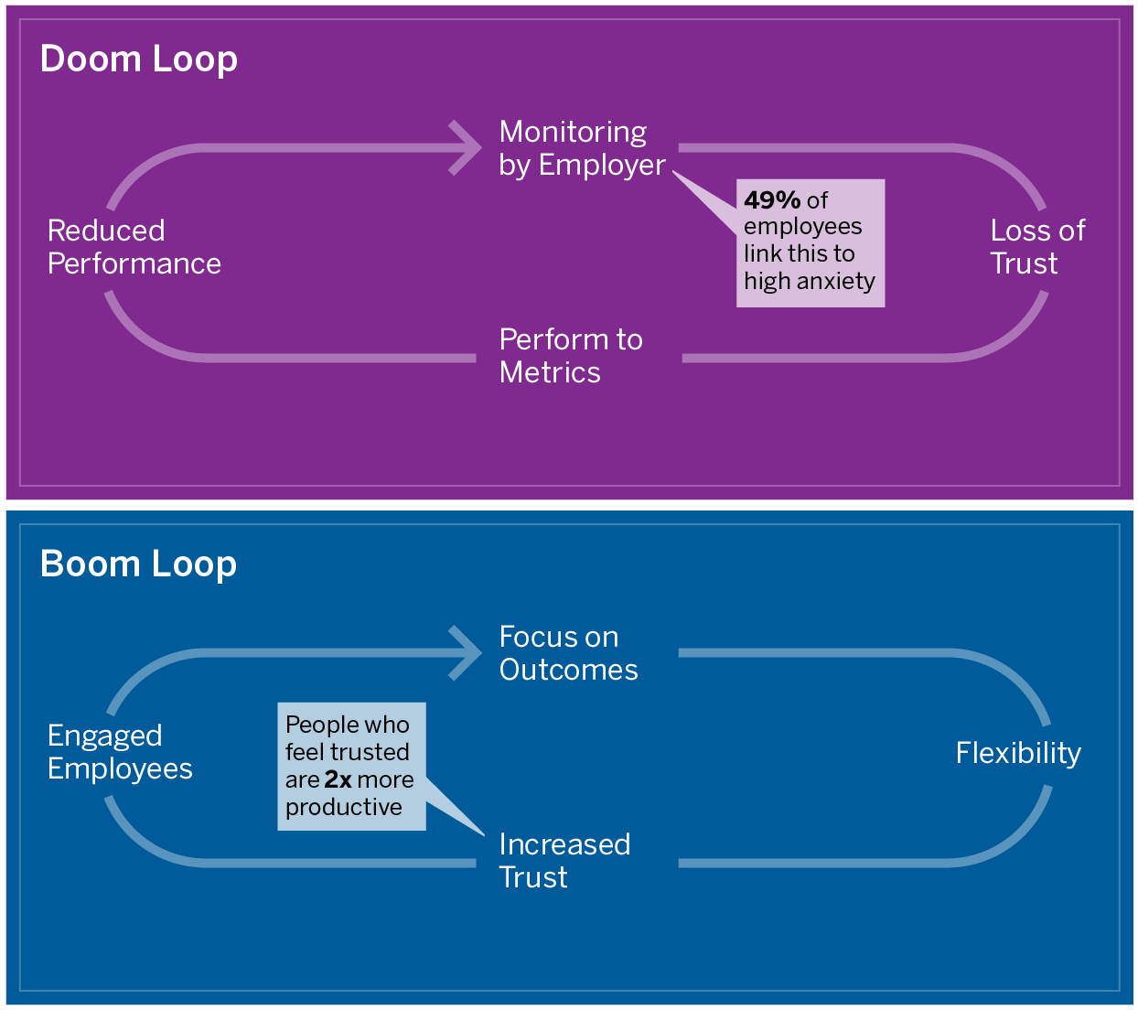
Source for loops: Future Forum
Anxiety statistic: Centre for Transformative Work Design; productivity statistic: Slack
More to the point, monitoring does not work. It’s easy enough for employees to perform to the system by scheduling when their emails go out, keeping their status active online even when they’re not working, or buying mouse jigglers. While this might seem like cheating the system, employees are reacting to the core issue, which is a lack of trust.
At the individual level, a lack of confidence that employees will do the right thing is corrosive to employee engagement. In a Slack survey, people who said they felt trusted by their employer reported twice the productivity of those who didn’t feel trusted, and they were 30% more likely to say they put in extra effort at work. Companies that don’t exhibit that trust also diminish passion.
The Real Impact of Return-to-Office Mandates
RTO mandates do have an impact — and it’s pretty much all negative. The same study that found that RTO mandates have had no impact on the financial performance of the S&P 500 did find one enduring effect: significant declines in employees’ job satisfaction.
Forcing people who’ve been effective working from home three or four days a week to commute to the office instead is a recipe for grief. Some 75% of people who aren’t happy with their level of flexibility said they will look for new jobs, according to Future Forum research.
The group most likely to leave in the face of mandated RTO are high-performing employees.
Who’s most likely to leave? Women, caregivers, and other historically underrepresented groups at work, to start. The same Future Forum research found that 59% of working mothers want to work from home three or more days a week — as do 47% of working fathers. Flexible work is feminist, as the headline on a Fortune article by Erin Grau so eloquently put it. We’ve also seen for four years that Black, Latine, and Asian American office workers value flexibility more than their White colleagues do — with the ability to dial in and out offering a respite from code-switching. Forcing the march to the office undermines the ability to build inclusive, not just diverse, organizations.
If none of that captures your attention as a leader, how about this: A Gartner survey of more than 2,000 office workers found that the group most likely to leave are high performers, where “intent to stay” in the face of a mandated RTO dropped 16% — compared with 8% for the average employee. For top talent, the signal “We don’t trust you” stings deeply. These employees are already going above and beyond, but capricious policies tell them that appearances matter more than results.
Building the Boom Loop: The Outcomes-Driven Organization
The impact is clear: Mandates and monitoring lead to not only decreased employee satisfaction, retention issues, and a loss of trust but also to lower performance on what matters most to the C-suite — business results.
Conversely, companies that build trust outperform their peers financially. Institute for Corporate Productivity research showed that employees at high-performance companies (organizations that outperformed industry peers on factors like revenue growth, profitability, and customer satisfaction) were 11 times more likely to say they had senior leaders and managers who trusted them to do their jobs.
Trust and performance come from building alignment on how to measure results and drive accountability. When companies offer trust, flexibility, and a focus on outcomes, they see greater engagement and productivity, which is what I call the boom loop.
Organizations that have figured out how to do this — or that are hoping to — know that clarity around the most important outcomes the organization is trying to drive is the starting point. Getting there requires hard discussions and decision-making at the executive level, and clear communication up and down the organization.
There are many facets to getting to this kind of clarity. The long-term purpose of the organization needs to lead to near-term objectives and short-term ways of measuring progress. Those objectives and outcomes need to be prioritized — what’s most important for the organization to accomplish — with a well-defined understanding of who is accountable for performance.
Done right, exercises to get clarity around outcomes and priorities result in companies saying no (or at least “not now”) to a wide variety of activities. This will feel painful to at least part of the organization. (Google, which had a well-known objectives and key results process in its early days, had a set of OKRs when I was there that was so broad that nothing was off the table.)
Anyone who’s worked in an organization of more than a few hundred people knows that what I’ve just described can be a massive shift that requires effort, leadership commitment, and hard decisions. But once you’re there, magic things can happen.
Teams can be given the flexibility to find the right path to the outcomes they need to achieve and ways to ask for help when they need it. Flexibility at the team level leads to individual flexibility — and flexibility leads to trust.
A company driven by measuring outcomes instead of monitoring employees will allow for flexibility about where and even when people work. Most people want some time together with their teams and some time at home. Teams that figure out a regular rhythm that works for them perform best. Many executives are aware of this, which explains why, in a Conference Board survey, 27% of U.S. CEOs, 30% of Europe CEOs, and 13% of Latin America CEOs said that “maintain hybrid work” is a human capital priority in 2024, whereas only 4% to 6% of CEOs across those regions wanted to drive a full-time, five-day-a-week return to the office.
The bottom line is that when trust is balanced with accountability, people and organizations will thrive. The time employees save by not having to commute can be put toward their jobs or their personal lives. Judging employees on the outcomes they drive, not whether they’re showing up to an office after a grueling hour in traffic or on public transportation, reinforces two key elements: first, that the company takes accountability for performance seriously, and second, that people will be rewarded for their performance. Instead of focusing on internal debates about policies, mandates, and monitoring, employees can focus on delivering outcomes.
That’s the boom loop. It’s time to go build it.

